Lab Sheet 09

1.

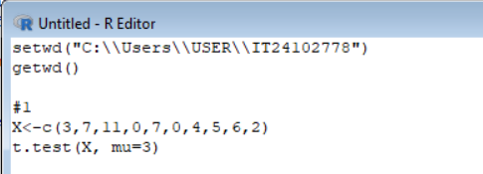

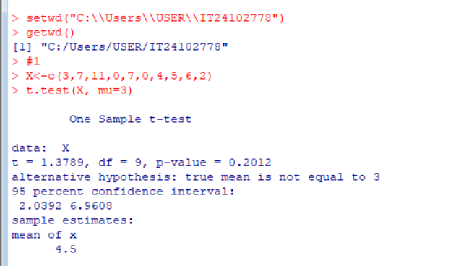

2.(i,ii)

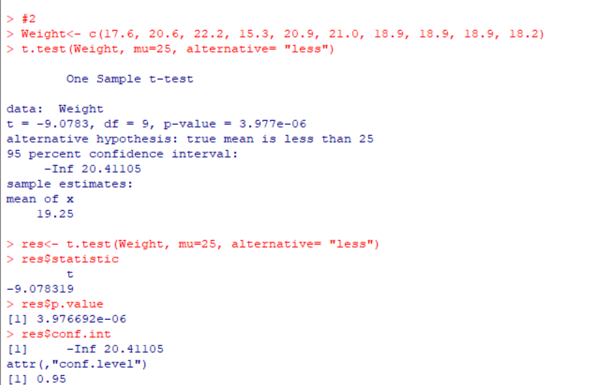

3.

Exercise

1.

